2018 Meet Greece Music Journey

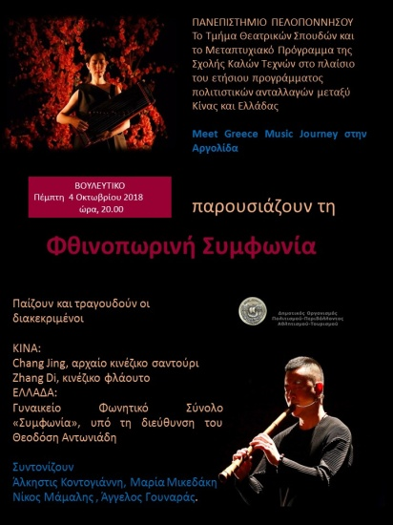

Collaborating Bodies: 2018 Meet Greece Music Journey and Theatre Studies Department, University of the Peloponnese

Academic Co-ordinators: Alkestis Kontogianni (Professor Emerita), Marina Kotzamani (Associate Professor), Maria Mikedaki (Assistant Professor), Angelos Gounaras (Tutor)

Dates: 28/9/ 2018 and 4/10/2018.

Other Collaborators: Chang Jing, Zhang Di, Miao Bin, female musical ensemble «Symphony», Theodosis Antoniadis, Giannis Nonis.

Participating Students: Vera Kitna, Elisabeth Kenanoglou.

Summary: The Theatre Studies Department participated in the annual programme of cultural exchange between China and Greece by organizing a series of events which included: guided tour at the exhibition “Writing and Reading: Heinrich Schliemann and Antonios” at the Gennadius Library of Athens (M. Kotzamani), guided tour at the archaeological site of Mycenae and the ancient theatre excavated by Schliemann (M. Mikedaki), evening with music at Vouleutikon, Nafplion, followed by a workshop of music and theatre.

Relevant links and publicity:

- http://www.meetculture.cn/meet-greece-music-journey
- http://ts.uop.gr/gr/video

